1)

TRUTH TABLE:

(a, b, cin) (a, b’, cin)

|  |  |  |  |  |  |  |  |
| --- | --- | --- | --- | --- | --- | --- | --- |
| **cin** | **a** | **b** | **b’** | **t = 0** | | **t = 1** | |
| **cout** | **s** | **cout** | **s** |
| **0** | **0** | **0** | **1** | 0 | 0 | 0 | 1 |
| **0** | **0** | **1** | **0** | 0 | 1 | 0 | 0 |
| **0** | **1** | **0** | **1** | 0 | 1 | 1 | 0 |
| **0** | **1** | **1** | **0** | 1 | 0 | 0 | 1 |
| **1** | **0** | **0** | **1** | 0 | 1 | 1 | 0 |
| **1** | **0** | **1** | **0** | 1 | 0 | 0 | 1 |
| **1** | **1** | **0** | **1** | 1 | 0 | 1 | 1 |
| **1** | **1** | **1** | **0** | 1 | 1 | 1 | 0 |

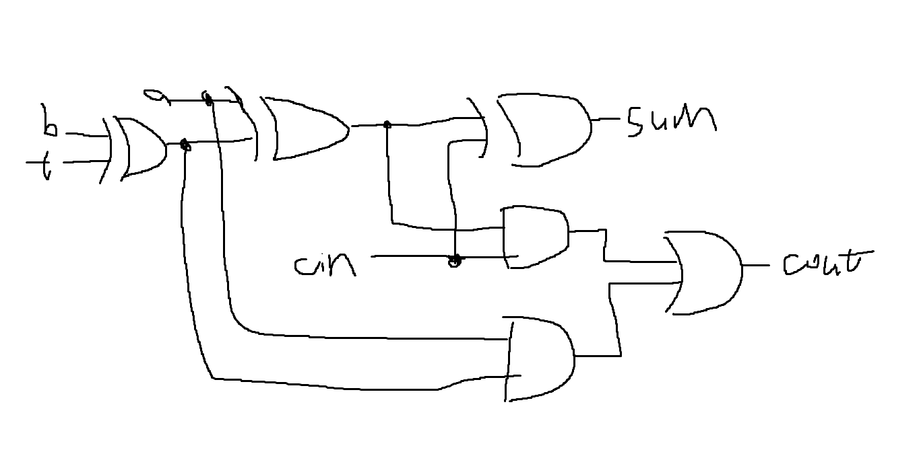

At most this travels through four gates, which is minimal. With only one gate, the adder becomes a subtractor as well.

2)

2.1

|  |  |  |  |  |  |  |  |  |  |  |  |  |
| --- | --- | --- | --- | --- | --- | --- | --- | --- | --- | --- | --- | --- |
| **Column i** | **15-10** | **9** | **8** | **7** | **6** | **5** | **4** | **3** | **2** | **1** | **0** | **-1** |
| **238** | 0 | 0 | 0 | 1 | 1 | 1 | 0 | 1 | 1 | 1 | 0 | 0 |
| **675** | 0 | 1 | 0 | 1 | 0 | 1 | 0 | 0 | 0 | 1 | 1 | 0 |
| **(Gi:i, Pi:i)** | (0, 0) | (0,1) | (0,0) | (1,1) | (1,0) | (1,1) | (0,0) | (1,0) | (1,0) | (1,1) | (0,1) | (0, 0) |

1st Stage:

G0:-1 = G0:0 + P0:0G-1:-1 = 0

G2:1 = G2:2 + P2:2G1:1 = 1

G4:3 = G4:4 + P4:4G3:3 = 0

G6:-5 = G6:6 + P6:6G5:5 = 1

G8:7 = G8:8 + P8:8G7:7 = 0

G10:9 = G10:10 + P10:10G9:9 = 0

G12:11 = G12:12 + P12:12G11:11 = 0

G14:13 = G14:14 + P14:14G13:13 = 0

P0:-1 = P0:0P-1:-1 = 0

P2:1 = P2:2P1:1 = 1

P4:3 = P4:4P3:3 = 0

P6:5 = P6:6P5:5 = 1

P8:7 = P8:8P7:7 = 0

P10:9 = P10:10P9:9 = 0

P12:11 = P12:12P11:11 = 0

P14:13 = P14:14P13:13 = 0

|  |  |  |  |  |  |  |  |  |
| --- | --- | --- | --- | --- | --- | --- | --- | --- |
| **Column i:j** | **14:13** | **12:11** | **10:9** | **8:7** | **6:5** | **4:3** | **2:1** | **0:-1** |
| **(Gi:j, Pi:j)** | (0, 0) | (0, 0) | (0,0) | (0,0) | (1,1) | (0,0) | (1,1) | (0,0) |

2nd stage:

G1:-1 = G1:1 + P1:1G0:-1 = 1

G2:-1 = G2:1 + P2:1G0:-1 = 1

G5:3 = G5:5 + P5:5G4:3 = 1

G6:3 = G6:5 + P6:5G4:3 = 1

G9:7 = G9:9 + P9:9G8:7 = 0

G10:7 = G10:9 + P10:9G8:7 = 0

G13:11 = G13:13 + P13:13G12:11 = 0

G14:11 = G14:13 + P14:13G12:11 = 0

P1:-1 = P1:1P0:-1 = 0

P2:-1 = P2:1P0:-1 = 0

P5:3 = P5:5P4:3 = 0

P6:3 = P6:5P4:3 = 0

P9:7 = P9:9P8:7 = 0

P10:7 = P10:PG8:7 = 0

P13:11 = P13:13P12:11 = 0

P14:11 = P14:13P12:11 = 0

|  |  |  |  |  |  |  |  |  |
| --- | --- | --- | --- | --- | --- | --- | --- | --- |
| **Column i:j** | **14:11** | **13:11** | **10:7** | **9:7** | **6:3** | **5:3** | **2:-1** | **1:-1** |
| **(Gi:j, Pi:j)** | (0, 0) | (0, 0) | (0,0) | (0,0) | (1,0) | (1,0) | (1,0) | (1,0) |

3rd stage:

G3:-1 = G3:3 + P3:3G2:-1 = 1

G4:-1 = G4:3 + P4:3G2:-1 = 0

G5:-1 = G5:3 + P5:3G2:-1 = 1

G6:-1 = G6:3 + P6:3G2:-1 = 1

G11:7 = G11:11 + P11:11G10:7 = 0

G12:7 = G12:11 + P12:11G10:7 = 0

G13:7 = G13:11 + P13:11G10:7 = 0

G14:7 = G14:11 + P14:11G10:7 = 0

P3:-1 = P3:3P2:-1 = 0

P4:-1 = P4:3P2:-1 = 0

P5:-1 = P5:3P2:-1 = 0

P6:-1 = P6:3P2:-1 = 0

P11:7 = P11:11P10:7 = 0

P12:7 = P12:11P10:7 = 0

P13:7 = P13:11P10:7 = 0

P14:7 = P14:11P10:7 = 0

|  |  |  |  |  |  |  |  |  |
| --- | --- | --- | --- | --- | --- | --- | --- | --- |
| **Column i:j** | **14:7** | **13:7** | **12:7** | **11:7** | **6:-1** | **5:-1** | **4:-1** | **3:-1** |
| **(Gi:j, Pi:j)** | (0, 0) | (0, 0) | (0,0) | (0,0) | (1,0) | (1,0) | (1,0) | (1,0) |

4th stage:

G7:-1 = G7:7 + P7:7G6:-1 = 1

G8:-1 = G8:7 + P8:7G6:-1 = 0

G9:-1 = G9:7 + P9:7G6:-1 = 0

G10:-1 = G9:7 + P9:7G6:-1 = 0

G11:-1 = G11:7 + P11:7G6:-1 = 0

G12:-1 = G12:7 + P12:7G6:-1 = 0

G13:-1 = G13:7 + P13:7G6:-1 = 0

G14:-1 = G14:7 + P14:7G6:-1 = 0

P7:-1 = P7:7P6:-1 = 1

P8:-1 = P8:7P6:-1 = 0

P9:-1 = P9:7P6:-1 = 0

P10:-1 = P9:7P6:-1 = 0

P11:-1 = P11:7P6:-1 = 0

P12:-1 = P12:7P6:-1 = 0

P13:-1 = P13:7P6:-1 = 0

P14:-1 = P14:7P6:-1 = 0

|  |  |  |  |  |  |  |  |  |
| --- | --- | --- | --- | --- | --- | --- | --- | --- |
| **Column i:j** | **14:-1** | **13:-1** | **12:-1** | **11:-1** | **10:-1** | **9:-1** | **8:-1** | **7:-1** |
| **(Gi:j, Pi:j)** | (0, 0) | (0, 0) | (0,0) | (0,0) | (0,0) | (0,0) | (0,0) | (1,0) |

|  |  |  |  |  |  |  |  |  |  |  |  |  |
| --- | --- | --- | --- | --- | --- | --- | --- | --- | --- | --- | --- | --- |
| **Column i** | **15-11** | **10** | **9** | **8** | **7** | **6** | **5** | **4** | **3** | **2** | **1** | **0** |
| **238** | 0 | 0 | 0 | 0 | 1 | 1 | 1 | 0 | 1 | 1 | 1 | 0 |
| **675** | 0 | 0 | 1 | 0 | 1 | 0 | 1 | 0 | 0 | 0 | 1 | 1 |
| **Gi-1:-1** | 0 | 0 | 0 | 1 | 1 | 1 | 0 | 1 | 1 | 1 | 0 | 0 |
| **Sum** | 0 | 0 | 1 | 1 | 1 | 0 | 0 | 1 | 0 | 0 | 0 | 1 |

**= 01110010001 = 913**

2.2

|  |  |  |  |  |  |  |  |  |  |  |  |  |
| --- | --- | --- | --- | --- | --- | --- | --- | --- | --- | --- | --- | --- |
| **Column i** | **15-10** | **9** | **8** | **7** | **6** | **5** | **4** | **3** | **2** | **1** | **0** | **-1** |
| **432** | 0 | 0 | 1 | 1 | 0 | 1 | 1 | 0 | 0 | 0 | 0 |  |
| **521** | 0 | 1 | 0 | 0 | 0 | 0 | 0 | 1 | 0 | 0 | 1 |  |
| **(Gi:i, Pi:i)** | (0, 0) | (0,1) | (1,0) | (1,0) | (0,0) | (1,0) | (1,0) | (0,1) | (0,0) | (0,0) | (0,1) | (0, 0) |

1st stage:

G0:-1 = G0:0 + P0:0G-1:-1 = 0

G2:1 = G2:2 + P2:2G1:1 = 0

G4:3 = G4:4 + P4:4G3:3 = 0

G6:5 = G6:6 + P6:6G5:5 = 0

G8:7 = G8:8 + P8:8G7:7 = 0

G10:9 = G10:10 + P10:10G9:9 = 0

G12:11 = G12:12 + P12:12G11:11 = 0

G14:13 = G14:14 + P14:14G13:13 = 0

P0:-1 = P0:0P-1:-1 = 0

P2:1 = P2:2P1:1 = 0

P4:3 = P4:4P3:3 = 1

P6:5 = P6:6P5:5 = 0

P8:7 = P8:8P7:7 = 1

P10:9 = P10:10P9:9 = 0

P12:11 = P12:12P11:11 = 0

P14:13 = P14:14P13:13 = 0

|  |  |  |  |  |  |  |  |  |
| --- | --- | --- | --- | --- | --- | --- | --- | --- |
| **Column i:j** | **14:13** | **12:11** | **10:9** | **8:7** | **6:5** | **4:3** | **2:1** | **0:-1** |
| **(Gi:j, Pi:j)** | (0, 0) | (0, 0) | (0,0) | (0,1) | (0,0) | (0,1) | (0,0) | (0,0) |

2nd stage:

G1:-1 = G1:1 + P1:1G0:-1 = 0

G2:-1 = G2:1 + P2:1G0:-1 = 0

G5:3 = G5:5 + P5:5G4:3 = 0

G6:3 = G6:5 + P6:5G4:3 = 0

G9:7 = G9:9 + P9:9G8:7 = 0

G10:7 = G10:9 + P10:9G8:7 = 0

G13:11 = G13:13 + P13:13G12:11 = 0

G14:11 = G14:13 + P14:13G12:11 = 0

P1:-1 = P1:1P0:-1 = 0

P2:-1 = P2:1P0:-1 = 0

P5:3 = P5:5P4:3 = 1

P6:3 = P6:5P4:3 = 0

P9:7 = P9:9P8:7 = 1

P10:7 = P10:PG8:7 = 0

P13:11 = P13:13P12:11 = 0

P14:11 = P14:13P12:11 = 0

|  |  |  |  |  |  |  |  |  |
| --- | --- | --- | --- | --- | --- | --- | --- | --- |
| **Column i:j** | **14:11** | **13:11** | **10:7** | **9:7** | **6:3** | **5:3** | **2:-1** | **1:-1** |
| **(Gi:j, Pi:j)** | (0, 0) | (0, 0) | (0,0) | (0,1) | (0,0) | (0,1) | (0,0) | (0,0) |

3rd stage:

G3:-1 = G3:3 + P3:3G2:-1 = 0

G4:-1 = G4:3 + P4:3G2:-1 = 0

G5:-1 = G5:3 + P5:3G2:-1 = 0

G6:-1 = G6:3 + P6:3G2:-1 = 0

G11:7 = G11:11 + P11:11G10:7 = 0

G12:7 = G12:11 + P12:11G10:7 = 0

G13:7 = G13:11 + P13:11G10:7 = 0

G14:7 = G14:11 + P14:11G10:7 = 0

P3:-1 = P3:3P2:-1 = 0

P4:-1 = P4:3P2:-1 = 0

P5:-1 = P5:3P2:-1 = 0

P6:-1 = P6:3P2:-1 = 0

P11:7 = P11:11P10:7 = 0

P12:7 = P12:11P10:7 = 0

P13:7 = P13:11P10:7 = 0

P14:7 = P14:11P10:7 = 0

|  |  |  |  |  |  |  |  |  |
| --- | --- | --- | --- | --- | --- | --- | --- | --- |
| **Column i:j** | **14:7** | **13:7** | **12:7** | **11:7** | **6:-1** | **5:-1** | **4:-1** | **3:-1** |
| **(Gi:j, Pi:j)** | (0, 0) | (0, 0) | (0,0) | (0,0) | (0,0) | (0,0) | (0,0) | (0,0) |

4th stage:

G7:-1 = G7:7 + P7:7G6:-1 = 0

G8:-1 = G8:7 + P8:7G6:-1 = 0

G9:-1 = G9:7 + P9:7G6:-1 = 0

G10:-1 = G9:7 + P9:7G6:-1 = 0

G11:-1 = G11:7 + P11:7G6:-1 = 0

G12:-1 = G12:7 + P12:7G6:-1 = 0

G13:-1 = G13:7 + P13:7G6:-1 = 0

G14:-1 = G14:7 + P14:7G6:-1 = 0

P7:-1 = P7:7P6:-1 = 0

P8:-1 = P8:7P6:-1 = 0

P9:-1 = P9:7P6:-1 = 0

P10:-1 = P9:7P6:-1 = 0

P11:-1 = P11:7P6:-1 = 0

P12:-1 = P12:7P6:-1 = 0

P13:-1 = P13:7P6:-1 = 0

P14:-1 = P14:7P6:-1 = 0

|  |  |  |  |  |  |  |  |  |
| --- | --- | --- | --- | --- | --- | --- | --- | --- |
| **Column i:j** | **14:-1** | **13:-1** | **12:-1** | **11:-1** | **10:-1** | **9:-1** | **8:-1** | **7:-1** |
| **(Gi:j, Pi:j)** | (0, 0) | (0, 0) | (0,0) | (0,0) | (0,0) | (0,0) | (0,0) | (0,0) |

|  |  |  |  |  |  |  |  |  |  |  |  |
| --- | --- | --- | --- | --- | --- | --- | --- | --- | --- | --- | --- |
| **Column i** | **15-11** | **9** | **8** | **7** | **6** | **5** | **4** | **3** | **2** | **1** | **0** |
| **432** | 0 | 0 | 1 | 1 | 0 | 1 | 1 | 0 | 0 | 0 | 0 |
| **521** | 0 | 1 | 0 | 0 | 0 | 0 | 0 | 1 | 0 | 0 | 1 |
| **Gi-1:-1** | 0 | 0 | 0 | 0 | 0 | 0 | 0 | 0 | 0 | 0 | 0 |
| **Sum** | 0 | 1 | 1 | 1 | 0 | 1 | 1 | 1 | 0 | 0 | 1 |

**= 1110111001 = 953**

3)

3.1

For each digit, we have 3 bits

Weight 0: (0, 0, 0)

Weight 1: (0, 0, 1), (0, 1, 0), (1, 0, 0)

Weight 2: (0, 1, 1), (1, 0, 1), (1, 1, 0)

Weight 3: (1, 1, 1)

Algorithm:

1. Convert the 1st addend to the redundant number system.
2. From the 5 numbers, convert them to carry save additions. Convert back to binary.
3. Convert the 1st of the remaining binary values into its redundant number system.
4. Add those two numbers.

3.2

|  |  |  |  |  |  |
| --- | --- | --- | --- | --- | --- |
| **Weight** | **16** | **8** | **4** | **2** | **1** |
| **12** | 0 | 1 | 1 | 0 | 0 |
| **7** | 0 | 0 | 1 | 1 | 1 |
| **9** | 0 | 1 | 0 | 0 | 1 |
| **10** | 0 | 1 | 0 | 1 | 0 |
| **17** | 1 | 0 | 0 | 0 | 1 |

|  |  |  |  |  |  |
| --- | --- | --- | --- | --- | --- |
| 0 | 1 | 1 | 0 | 0 | 1 |
| 0 | 1 | 1 | 1 | 1 | 0 |
| 0 | 0 | 0 | 0 | 0 | 0 |
| **1** | **1** | **0** | **1** | **1** | **1** |

= 110111 = 55

|  |  |  |  |  |  |
| --- | --- | --- | --- | --- | --- |
| **Weight** | 16 | 8 | 4 | 2 | 1 |
| **11** | 0 | 1 | 0 | 1 | 1 |
| **5** | 0 | 0 | 1 | 0 | 1 |
| **14** | 0 | 1 | 1 | 1 | 0 |
| **16** | 1 | 0 | 0 | 0 | 0 |

|  |  |  |  |  |  |
| --- | --- | --- | --- | --- | --- |
| 0 | 1 | 0 | 0 | 0 | 0 |
| 0 | 1 | 1 | 1 | 1 | 0 |
| 0 | 0 | 0 | 0 | 0 | 0 |
| **1** | **0** | **1** | **1** | **1** | **0** |

= 101110 = 46

|  |  |  |  |  |  |  |
| --- | --- | --- | --- | --- | --- | --- |
| **Weight** | 32 | 16 | 8 | 4 | 2 | 1 |
| **46** | 1 | 0 | 1 | 1 | 1 | 0 |

|  |  |  |  |  |  |  |
| --- | --- | --- | --- | --- | --- | --- |
| 0 | 0 | 1 | 1 | 0 | 0 | 1 |
| 1 | 0 | 0 | 1 | 1 | 0 | 0 |
| 0 | 0 | 0 | 0 | 0 | 0 | 0 |
| **1** | **1** | **0** | **0** | **1** | **0** | **1** |

= 1100101 = 101

3.3

Because we have 5 numbers, that is the case, as we will never go past 3 bits to hold 5 1s. So using 3 bits is all we need.

4)

4.1

|  |  |  |
| --- | --- | --- |
| **State** | **Instr** | **Op** |
| **S1** | done ← 1 |  |
| **S2** | A ← X | A ← Load(X) |
| **S2** | B ← Y | B ← Load(Y) |
| **S2** | C ← Z | C ← Load(Z) |
| **S3** | A ← A + B | A ← Add(A, B) |
| **S3** | B ← Inc(B) | B ← Inc(B) |
| **S4** | C ← Inc(C) | C ← Inc(C) |
| **S5** | A ← Inc(A) | A ← Inc(A) |
| **S6** | U ← A | Wire |
| **S6** | done ← 1 |  |

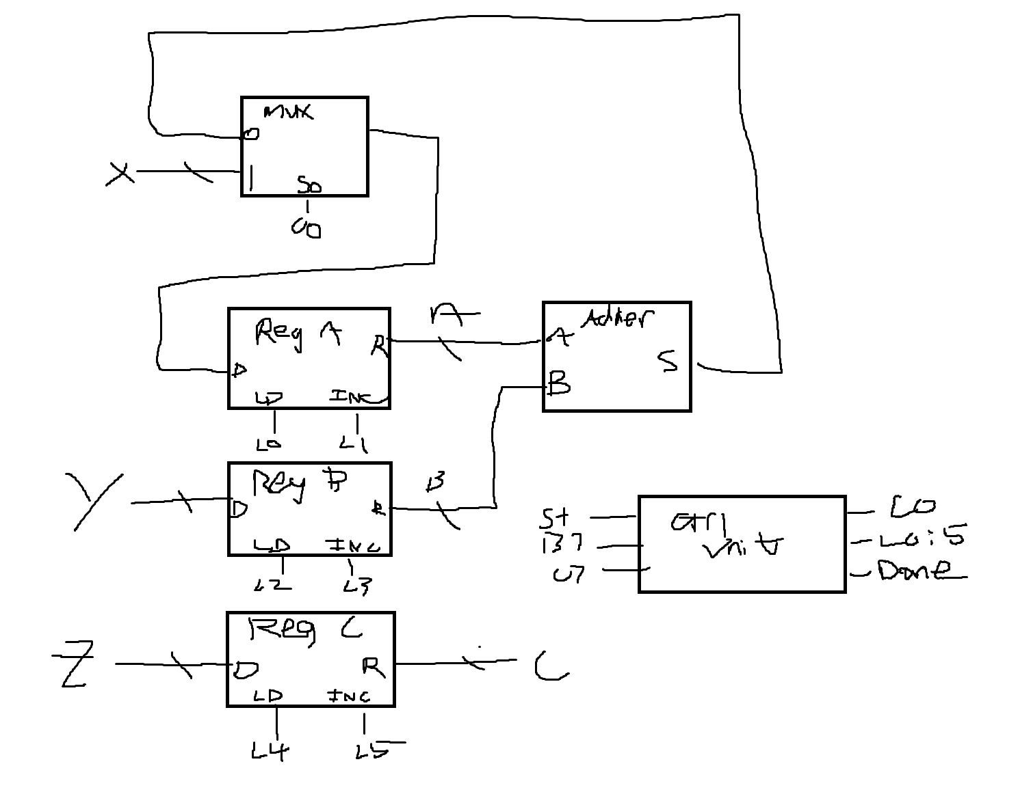

4.2

|  |  |  |  |  |  |  |  |  |
| --- | --- | --- | --- | --- | --- | --- | --- | --- |
|  | **L0** | **L1** | **L2** | **L3** | **L4** | **L5** | **c0** | **done** |
| **S0** | 0 | 0 | 0 | 0 | 0 | 0 | X | 1 |
| **S1** | 1 | 0 | 1 | 0 | 1 | 0 | 1 | 0 |
| **S2** | 1 | 0 | 0 | 1 | 0 | 0 | 0 | 0 |
| **S3** | 0 | 0 | 0 | 0 | 0 | 1 | X | 0 |
| **S4** | 0 | 1 | 0 | 0 | 0 | 0 | X | 0 |
| **S5** | 0 | 0 | 0 | 0 | 0 | 0 | X | 1 |

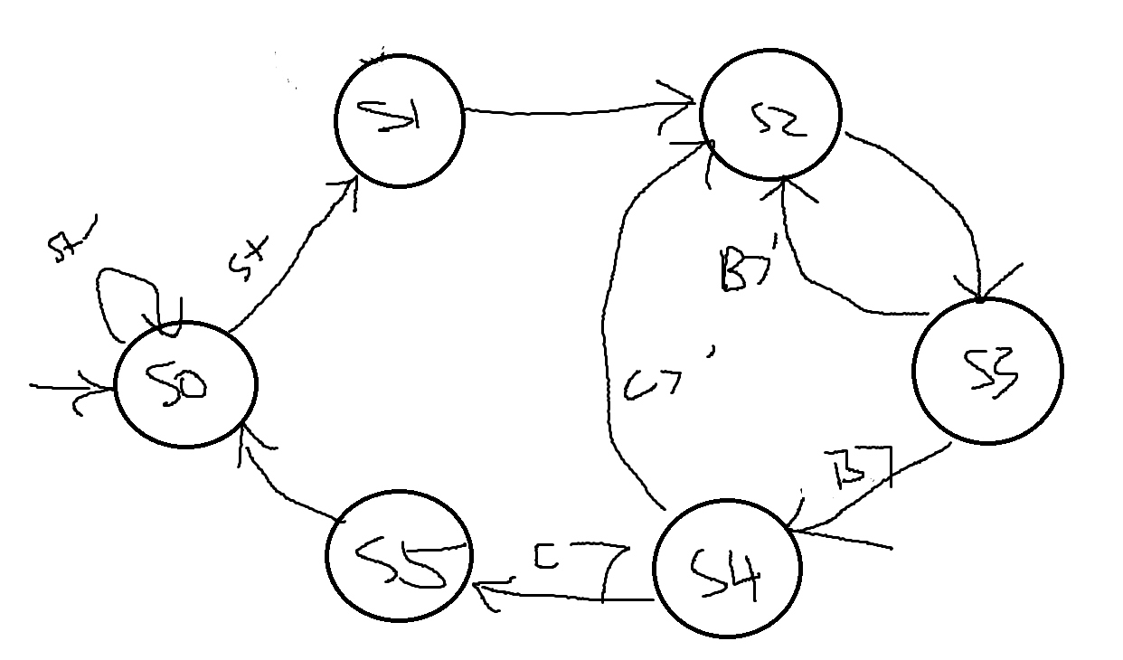

4.3

